June 2026
OADBY HILL WALKING CLUB NEWSLETTER

v
Contents
Club Announcements 2
Walking Routes 2
Walking Boots 2
2026/2027 Monthly Walk Destinations 2
OHWC New WhatsApp Community 2
Safeguarding 3
Charitable Endeavours 3
Tim, Elaine Akers, & Clare Savage: 26 Mile Mighty Hike around the Gower Peninsula for Macmillan Cancer Support (27th June 2026) 3
Lake District Trip – May 2027 4
Derwentwater Hotel, Lake District 4
WALKS 4
June’s Walk Report (by Gala Suarez) 4
June’s Mid-Month Local Walk (Led by TBC) 5
July’s Monthly Walk: Allgreave – Peak District 6
Coach Departs 6
Boot stop 6
Pub 6
Map 6
Walk Leaders 6
Booking Trips 6
Coach Fare 6
Cancellations - Members & Guests 6
Prospective Walkers 6
Walk Route Map 7
Boot/Toilet Stop 7
Essential Wear 7
Spring Walking Tips 8
Those Pesky Ticks! 8
Cotswold Outdoors Discount Card for Club Members 9
OHWC discount 9
Cotswold Outdoors Discount Card 10
Meetings 11
Club Media & Bank Details 12
OHWC Committee 2026– 2027 12

Club Announcements

Walking Routes
Can all club members look at the walking routes available on the OHWC website: https://www.oadbyhillwalkingclub.com, & also on the club WhatsApp group prior to joining each month’s coach trip, so the walk list can be passed round the coach more efficiently please. Each month’s walk routes are put up on the club website in the week before the monthly walk.

Walking Boots
Club members are reminded that when joining club walks, they must wear walking boots with ankle support. The only exception to this rule is if club members have a valid medical reason for not wearing boots with ankle support.

2026/2027 Monthly Walk Destinations
Adam Wakley has recently published the monthly OHWC walk destinations from July 2026 to April 2027. See below:
- 05 July 2026 Allgreave, Cheshire
- 02 August 2026 Dursley, Gloucestershire
- 06 September 2026 Langsett, Yorkshire
- 04 October 2026 Longnor, Staffordshire Peak District
- 01 November 2026 Long Shawlodge, Peak District
- 06 December 2026 Biggin, Derbyshire Peak District
- 03 January 2027 Wirksworth, Derbyshire
- 07 February 2027 Kingsley Holt, Leek
- 07 March 2027 Taddington, Derbyshire Peak District
- 04 April 2027 Andoversford, Cotswolds

OHWC New WhatsApp Community
By now all of you who were on the original club’s WhatsApp group chat may have realised that you have been tele-transported (Star Trek style!) to the Oadby Hillwalking Club Community. Any group chat related to OHWC is under this community now. I would love to encourage you all to join the WhatsApp Community if you haven’t yet!
This is how it works. Our OHWC Community is comprised of several groups:
- Announcements: Only admins can post here. Members can like the posts or reply to them, but cannot post. This is where all the important information will be kept, all in a nice standalone space, so people don’t have to scroll up & down to find the important bits (i.e., walks maps, routes, dates, events, etc).
- OHWC Chat: This is the chat you always had. We are trying to streamline it to a chat ONLY about OHWC related matters.
- OHWC Lakes 2027: This chat is for the people who have joined for next year’s Lake District Walking Holiday, or would still like to join us.
- General: This group came for free when I created the community. I am trying to make this a space where we can all talk about anything & everything we enjoy without taking over the main OHWC Chat group - we can post pics of our own trips, hikes, our hobbies, interesting articles or videos, etc. I have noticed that people have already started to use it this way.
Once you join the community, you can choose what group chat you want to join, stay on or leave. You can request to join groups if you automatically are not added, & if you don’t want to participate in the chats, then you can just stay only with the announcements.
I welcome all of your feedback & ideas to improve our WhatsApp community. Let’s make it great!

Safeguarding
The OHWC is committed to safeguarding in line with national legislation,& national & local guidelines. We ensure safeguarding by ensuring our club is run in a way which keeps our club members safe.
We all have a responsibility to safeguard adults & young people who are experiencing, or are at risk of, abuse & neglect.
The OHWC is committed to creating a culture of zero tolerance of harm to our club members which necessitates:
- The recognition of club members who may be at risk & the circumstances which may increase risk.
- Knowing how abuse, exploitation or neglect manifests itself.
- And being willing to report safeguarding concerns.
The OHWC Safeguarding Policy & associated procedures apply to all individuals who are involved in the OHWC, including the committee & the walk leaders, to all concerns about the safety of club members whilst taking part in club activities,& in the wider community.
All club members are encouraged to report any safeguarding concerns, no matter how trivial they seem to the club at OHWCsafeguarding@gmail.com.All such communications will be treated as strictly in-confidence& will be investigated thoroughly.
The OHWC Safeguarding Policy & Guidance document is on the club website at https://www.oadbyhillwalkingclub.com/safeguarding.html

Charitable Endeavours

Tim, Elaine Akers, & Clare Savage: 26 Mile Mighty Hike around the Gower Peninsula for Macmillan Cancer Support (27th June 2026)
Tim, Elaine, & Clare are walking 26 miles around the Gower Peninsula in Wales to help people living with cancer. This will be Elaine & Clare’s seventh Macmillan Mighty Hike, & Tim’s third.
The Gower Peninsula was the first place in Britain to be named a National Landscape with its sweeping beaches & beautiful cliffs. Elaine, Tim & Clare are starting their Mighty Hike in the ruins of Penrice Castle before walking clockwise around the peninsula, past Oxwich Bay Beach & Port Eynon Beach before circling back to Penrice Castle.
Elaine is walking this year in memory of her eldest brother Steve, who sadly passed away last in July last year aged 68 after a very sudden diagnosis of oesophageal cancer. Clare is also taking on this challenge in memory of Steve.
Tim is doing the Mighty Hike in memory of his brother-in-Law Steve, & in memory of his first wife Kim, who passed away in June 2007 at the age of 42 from a metastasis of breast cancer in her liver, lungs & brain.
Macmillan Cancer Support is a registered charity in England & Wales (261017) & has spent more than 100 years helping people living with cancer. From the moment someone is diagnosed with cancer, they are there with all the information, support & guidance needed, to help everyone with cancer live life as fully as they can. From personal experience, they were a massive support during & after Steve’s & Kim’s final illnesses.
Further information on the amazing work Macmillan Cancer Support does may be found here.
Elaine & Clare are still setting up their JustGiving pages for people to sponsor them. Please contact them privately for details.
Tim’s JustGiving page is here: Tim Akers's Gower Peninsula Mighty Hike JustGiving sponsorship page
Clare’s Just Giving page is here: Clare’s MacMillan Fundraising Page
Elaine, Tim & Clare are hugely grateful for any sponsorship received from Club members.

Lake District Trip – May 2027

Derwentwater Hotel, Lake District
The committee are pleased to confirm that we've taken the last rooms available in the Patterdale Hotel for our May 2026 trip.
There are now 28 members going to the Derwentwater Hotel in May 2027. There may still be some availability if other club members wish to attend the party. Telephone Alfa Travel on 01257 248000 should you wish to make enquiries.
Don’t forget to join our WhatsApp OHWC Lakes 2027 group for all the latest info about the trip!

WALKS

June’s Walk Report (by Gala Suarez)
Hayfield, Derbyshire (Sunday, 7thJune 2026) - Karl’s Walk (12.6 miles / 2388 ft - 728 m elevation)
And 6 intrepid hikers joined Karl on an initial over 12 mile hike, starting in Sparrowpit, with the intention of going up Jacob’s Ladder & over Kinder Scout. Firstly, crossing a couple of fields with grass so high that I thought I may get lost in the wilderness & never found again. On our “eggs & coffee” stop (as I like to call it), we bumped onto Adam’s hike; which was comprised of about 90% of the hikers on the bus; so they took over most of the land. Here is where I learnt what the big round brick construction in the distance was in fact the ventilation shaft over a train tunnel (thank you Geoff!).  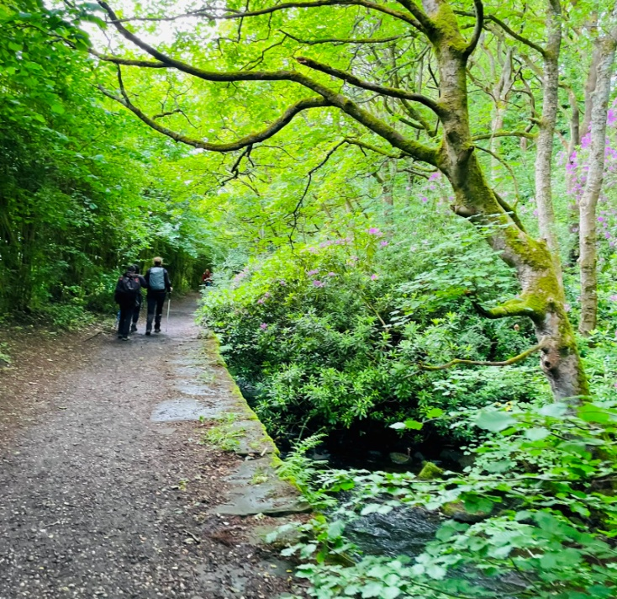  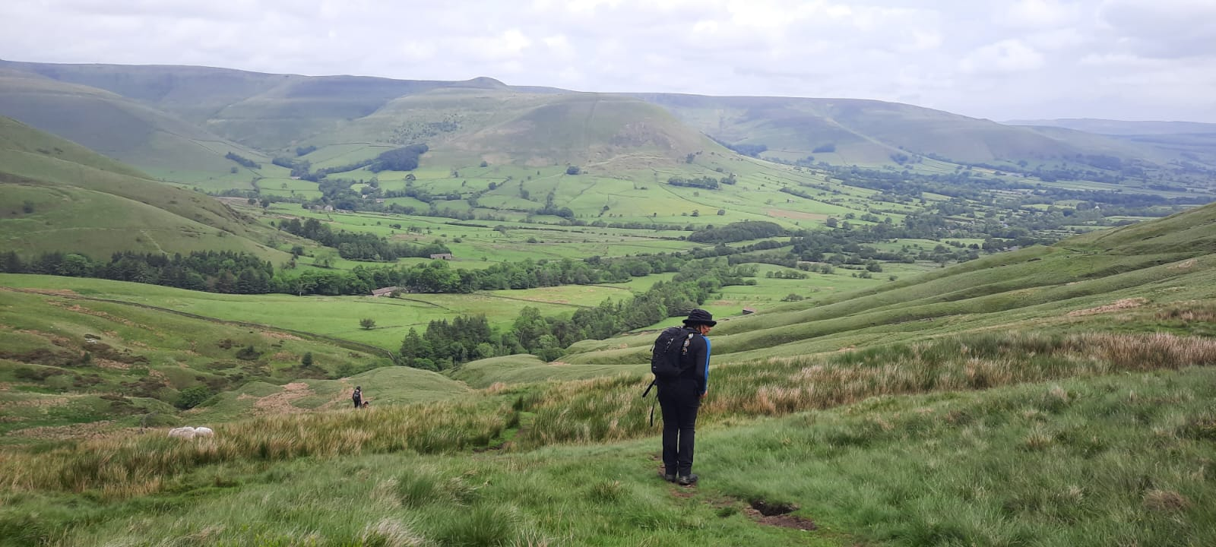  As we started walking away from Jacob’s Ladder we heard Catherine calling us in the distance.  When we told her about the “boot incident” she quickly looked for some laces inside her rucksack so we could try again to keep the sole attached to the boot (yes, Catherine does carry spare boot laces in her rucksack…who knew!). This did not work either, but against all odds, we all (person, boot & sole included) arrived safely at Hayfield’s “The George Hotel” for a WELL DESERVED pint or two.  Great hiking day as always! Thank you, Karl!   | 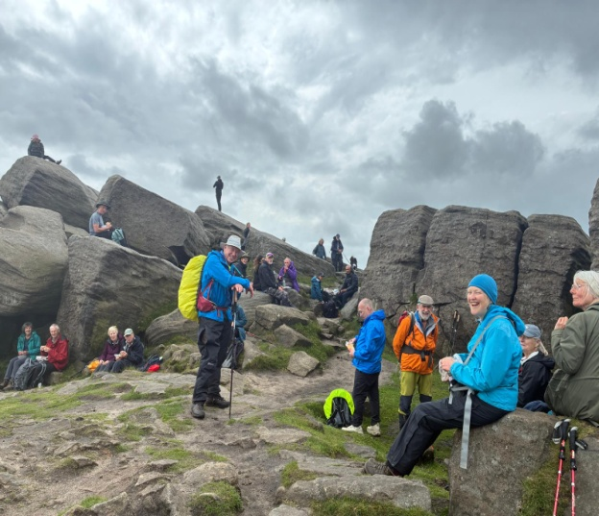  It soon became quite an eventful hike! We continued walking until we reached what looked like a small river. Karl stopped & assessed the situation. One of us had to say it: “We’re not going that way, right?”, to which Karl replied “It’s the only way we can go”. So, in our leader we trusted, & followed him crossing the river, using whatever big stones we could step on & holding onto branches for dear life, until we all managed to cross one by one. Nobody got even slightly wet, but one of us was to realize at that precise moment that the sole of her boot just came off! Holding the sole in her hand in disbelief, we all could not process this. I have never seen before a sole coming off such a new boot, clean off… just like that!  One of us went into “MacGyver mode” & devised a cunning plan, putting a very tight sock over the boot to hold the sole in place. Everyone rushed to pitch in & reassure our “soleless” walking mate. This worked for a little bit, but the intrepid hiker decided to just continue the hike without the sole.  This became trickier as we were walking up Jacob’s Ladder & the slowly thining out bare bottom of the boot was getting more & more worn. We regrouped & Karl decided that we needed to abort our original plan half way up jacob’s Ladder & cut the hike shorter, so our guide quickly rerouted.  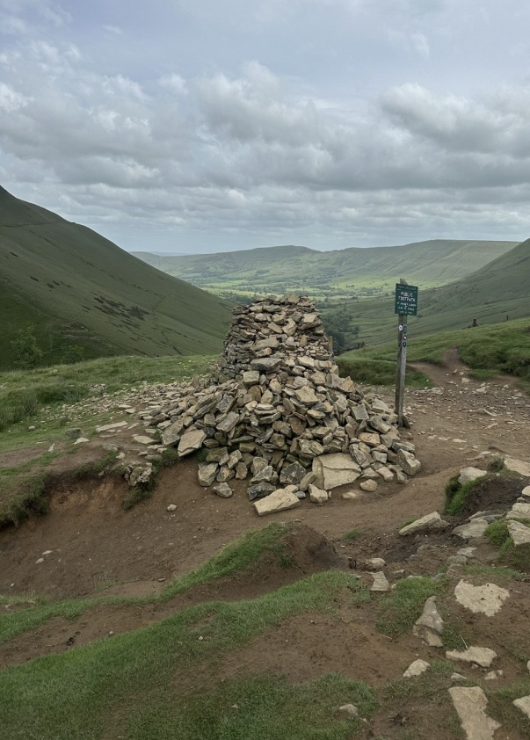

June’s Mid-Month Local Walk (Led by TBC)
Sadly, at the moment of release, there is no June Mid-Month Walk, as there are no volunteers to lead.


July’s Monthly Walk: Allgreave – Peak District
Sunday 5th July 2026
Coach Departs: Oadby Central Car Park (adjacent to the Trinity Methodist Church) at 8.00am sharp. | 

*Please note: The coach will leave the pub at 5.30pm.

Boot stop: Ashbourne bus station
Pub: The Rose & Crown
Map: OS Explorer OL1: OS Map of The Peak District - White Peak Area

 | Walk Leaders  Click on each leader to see their route’s OS map  - Kevin Millard (Long-15 miles)  - Karl Pochin(12 miles)  - Catherine Gwinnett (13 miles)  - Alison Beckett (11 miles)  - Barrie Stirrup (10 miles)  - Tim Akers (Short – 8.5 miles)
Booking Trips
When booking onto monthly & mid-month walks, please only use the club email rather than phone, text or word of mouth. Alternatively, for the monthly walks, put your name down on the list passed on the return monthly bus.
Coach Fare
Preferably by BACS to the bank details given at the end of this Newsletter.
- Adult Members £18
- Guests £20
- Junior/Student Members £12

Cancellations - Members & Guests
- Cancellations up to Tuesday midnight before the Sunday walk - no penalty.
- Cancellations thereafter - the full cost of the bus fare is due.

Prospective Walkers
If you have not put your name down on the list passed on the last coach trip, please contact ohwcmail@gmail.com to book a seat on the bus this month, prior to making a payment. You will receive a reply confirming the availability or otherwise of a seat. Please note that it is first come first served.
If you delay booking, you may not get a seat. Please do not turn up without booking & receiving confirmation that you have a place.
You must book a place on the coach in advance, or you may not be allowed to go on as it picks up members who have already booked a seat at various places on the ring road.
If you wish to be picked up from other places than Oadby Car Park, please mention where at time of booking & please be aware that very occasionally another Orbit coach may go past before ours arrives.
Walk Reminder
Essential information for all OHWC walks can be found on the OHWC Website here.Please ensure that you carry your completed Club Safety Form in the top pocket of your rucksack - it could help you in a difficult situation. N.B. Don’t forget to keep the form up to date. The form is available on the Club Website here.

Walk Route Map
Please go onto the News section of the Club website here & the Announcements section of our WhatsApp page - a few days before the monthly walk, to see a map showing the walk routes. Hopefully, this will speed up selecting your walk when signing up on the coach. The club has four to six OS maps available for Walk Leaders to use when leading walks.

Boot/Toilet Stop
Members are urged to keep the time taken at the boot stop to a minimum. At the end of the walk members should change their footwear & place dirty boots & rucksacks in the luggage locker before getting onto the coach, thus avoiding any congestion & mud in the coach.
Please do not wear dirty boots on the coach.
Those getting off the coach at Fosse Park & the Ring Road may alternatively put your dirty kit into a plastic bag & then take it onto the coach; thus, negating having to search for your gear in the bus luggage lockers.

Essential Wear
Members& guests must be suitably equipped. As a minimum this must include:

- Suitable waterproof walking boots that have adequate ankle support
- Waterproof coat & over-trousers
- Warm clothing
- An appropriate rucksack.
- Food & drink for the whole day
- For winter walking, all members are to carry a serviceable head torch in their rucksacks.
- A First Aid Kit is recommended

N.B. Jeans & trainers/sandals are NOT suitable. If you are not properly equipped for hillwalking, you may not be able to participate. Only Registered Assistance Dogs are allowed on club walks, except on mid-month walks at the discretion of the Walk Leader.

Spring Walking Tips

Those Pesky Ticks!

Symptoms of tick bites  Tick bites aren’t usually painful, but they may cause a red lump to develop where you were bitten. In some cases, tick bites may cause:  - Swelling  - Itchiness  - Blistering  - Bruising  Ticks in England can carry infections, including Lyme disease &, very rarely, tick-borne encephalitis (TBE). Ticks can be active all year round, but they are most active in the months April to July, & sometimes later in the autumn. Activity does continue over the winter months but at a significantly reduced level. | 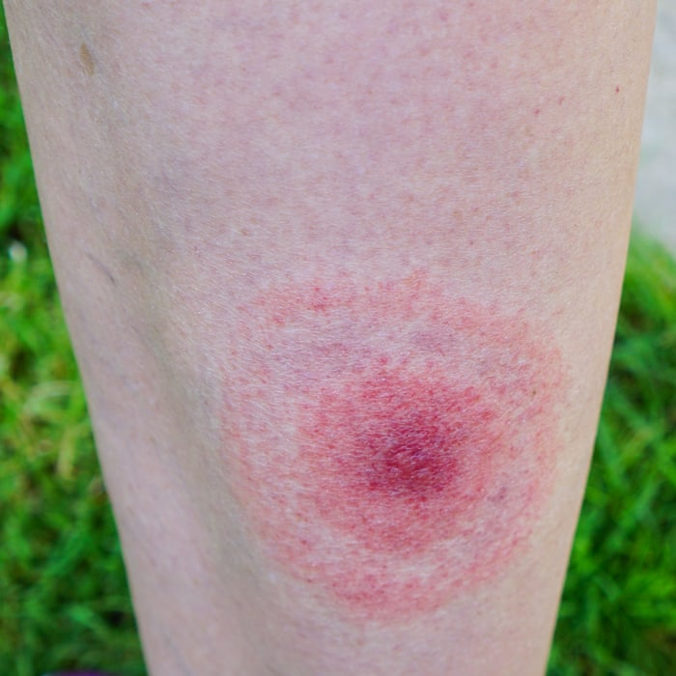
 | Preventing tick bites  - Keep to footpaths & avoid long grass when out walking  - Wear appropriate clothing (long-sleeved  shirt & trousers tucked into your socks)  - Wear light-coloured fabrics that may help  you spot a tick on your clothes  - Use insect repellent on exposed skin  - Check your skin for ticks  - Check your children skin for ticks, especially  the head & neck areas, including their  scalp make sure ticks are not brought home on  your clothes  - Check that pets do not bring ticks into your  home in their fur
How to remove ticks  If you’ve been bitten by a tick, it will attach to your skin. You should try to remove it as soon as possible. This helps to reduce the risk of getting a tick-borne infection, like Lyme disease. You should:  - Use a tick removal device or fine-toothed tweezers to gently grip the tick as close to the skin as possible.  - Pull steadily away from the skin without crushing the tick.  - Wash your skin with water & soap afterwards.  - Apply an antiseptic cream to the skin around the bite. | 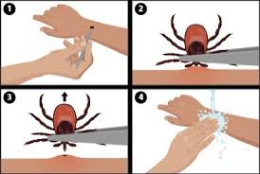

Many pharmacies and outdoor stores sell tick removal devices. These are useful if you often spend time in areas where there are ticks. If the tick’s mouthparts break off in the skin & cannot be removed, this may cause irritation.
However, they should fall out naturally in time.

Cotswold Outdoors Discount Card for Club Members
Once again, Cotswold Outdoors has allowed all Club members to apply for a Discount Card. This discount is for the personal use of club members only & must not be shared with others.
Club members benefit from:
- 15% discount in-store & online,
- Expertise, advice & guidance,
- Sustainability services,
- Explore More membership.

OHWC discount
OHWC Club Members will receive a 15% discount on full-priced items (excludes electronics & selected lines) both in-store & online with Cotswold Outdoor, Runners Need & Snow+Rock. The code to use is AF-RAMBLERS-MBB.
This discount is strictly for personal use only & must not be shared with non-club members. Cotswold Outdoors reserve the right to amend or cancel it with immediate effect if they find this code has been leaked to unauthorised persons in any way.
Explore More
Club members will need to sign up for their free Explore More benefits scheme to use the discount. This comes with its own benefits such as a 3-year warranty, a 100-day returns policy, Price Match Promise & much more! Members can sign up through any of the following brands:
- Cotswold Outdoor
- Runners Need
- Snow+Rock

Expertise, advice & guidance
The best way to tap into their outdoor expertise is for Club Members to book an in-store appointment at Cotswold Outdoor, Runners Need or Snow+Rock. This ensures one of our store specialists is on hand to help you get the best kit for your adventure.
Alternatively, Cotswold Indoor has a whole host of blogs online in our Advice & Inspiration areas. These include kit guides, itinerary ideas, inspirational stories & suggestions on how to be more sustainable. You can find these below:
- Cotswold Outdoor
- Runners Need
- Snow+Rock

Sustainability Services
For us the outdoors is everything, & across our three brands, we do everything we can to look after it for generations to come.
As a company, Cotswold Outdoors are working to become more sustainable, & they want to help their customers do their bit too. The services they offer to help with this are available across all their stores:
- Make The Right Choice
- Care & Proofing
- Recycle My Gear
- Recycle My Run
- Our planet

Cotswold Outdoors Discount Card
This year, Cotswold Outdoor, Runners Need & Snow+Rock have requested that OHWC Club members provide some sort of Club Membership Card to receive their discount. To that end, the club committee have decided to produce a Membership Card for club members to use if they want to take advantage of the discount offered.
I would suggest that members keep a photo of the OHWC membership card & the Ramblers Card together in their phone wallets for use in the stores.

Please print off this page & the next, & cut out the cards illustrated above & below.

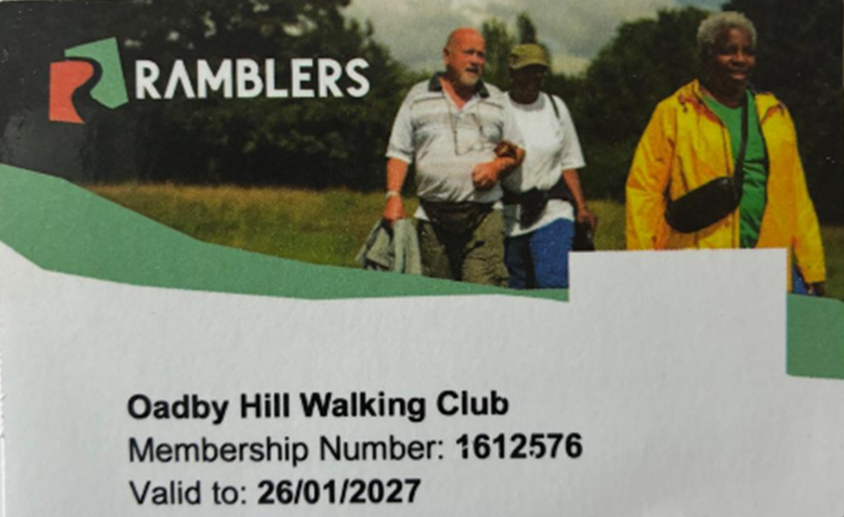

Meetings
Unless otherwise stated in this Newsletter or via email, monthly club meetings are held on the Wednesday following the Sunday coach walk at the Wigston Conservative Club, 38 Long Street, Wigston, Leicester, LE18 2AH at 7.30pm.
July’s meeting date/place TBC. All OHWC club members are welcome.
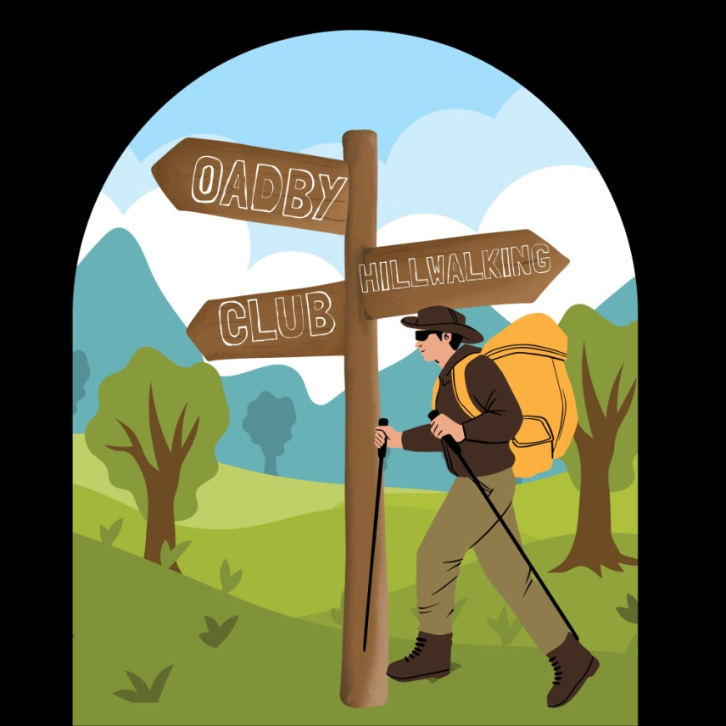

Club Media & Bank Details

Website | www.oadbyhillwalkingclub.com
Email | ohwcmail@gmail.com
Safeguarding Email | OHWCsafeguarding@gmail.com
Facebook | Private Group: Oadby Hillwalking Club group  Public Page: Oadby HIllwalking Club
Instagram  WhatsApp | Oadby Hillwalking Club  OHWC WhatsApp Community
Bank Details | Barclays Bank
Account Name | OHWC
Account Number | 50124990  Please quote surname & month of walk  (i.e., Smith July)
Sort code | 20-49-08

OHWC Committee 2026– 2027

Chair | Martin Beckett | 07748 674223
Treasurer | Martin Beckett | 07748 674223
Club Secretary | Ann Branson | 07726 334583
Membership Secretary | Mike Hewitt | 07484 731419
Walks Coordinator | Adam Wakley | 07720 328700
Communication & Social | Gala Suarez | 07810 063353
Safeguarding | Tim Akers | 07855 969183

